**Walchand College Of Engineering, Sangli**

**Department of Computer Science and Engineering**

**Subject: C&NS Lab**

**Batch: B4**

**Name: Gayatri Sopan Gade PRN:2020BTECS00210**

**Assignment 2**

**Title:** Cryptanalysis on Caesar cipher**.**

**Introduction:**

Cryptanalysis is the art of breaking codes and ciphers. The Caesar cipher is probably the easiest of all ciphers to break. Since the shift has to be a number between 1 and 25, (0 or 26 would result in an unchanged plaintext) we can simply try each possibility and see which one results in a piece of readable text.

Code:

Link: <https://github.com/gayatrig21/Cryptology-practicals/tree/Assignment-2>

Screenshots:

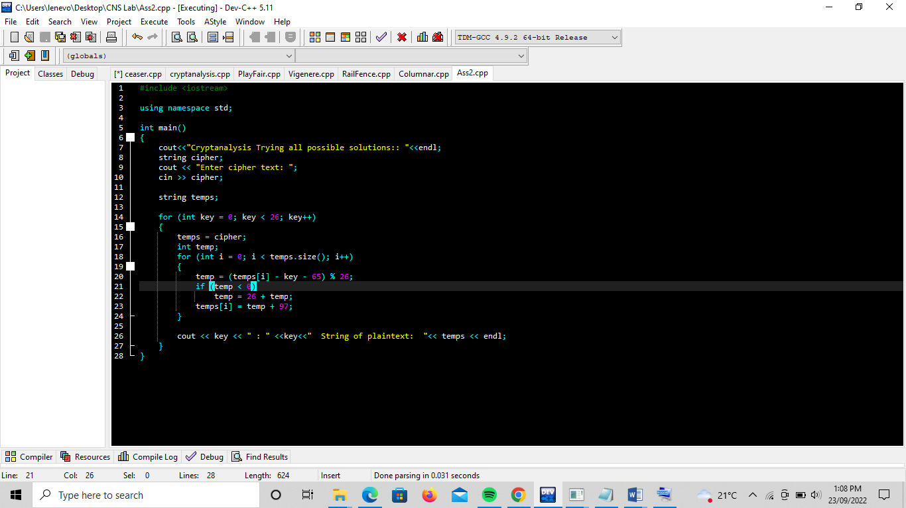

**Output**:

